**Julián Esteban Chacón**

**Paula Andrea Rojas**

**Diego Alejandro Sandoval**

**Mock ups y JSONs de App galería de fotos**

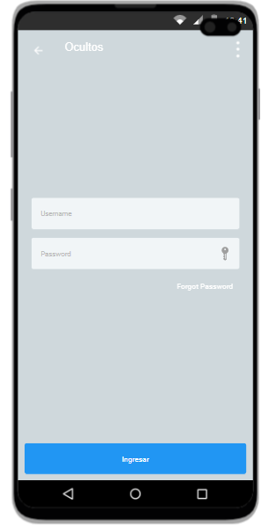**Inicio de sesión.**

**Petición:** POST

**Endpoint:** www.nombredominio.com/**singIn**

**Input:**

User: {

“username”: String,

“password”: String

}

**Output:**

User: {

“Id_user”: int,

“username”: String,

“password”: String

}

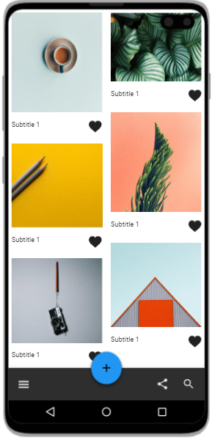

**Fotos:**

**Petición:** GET

**Endpoint:** www.nombredominio.com/ **photos/:id_user**

**Output:**

List <Photo> [

{

“id_user”: int,

“Id_photo”: int,

“date”: Date,

“id_folder”: int,

“favorite”: Boolean,

“url_image”: String

},

]

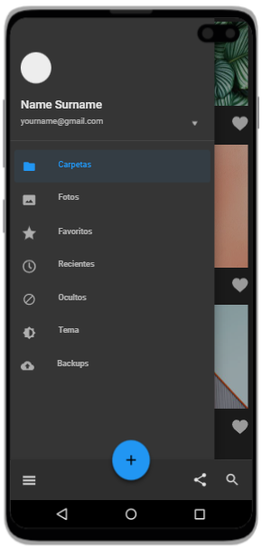

**Menú principal:**

**Petición:** GET

**Endpoint:** www.nombredominio.com/ **home/:** **id_user**

**Output:**

User: {

“id_user”: int,

“username”: String,

}

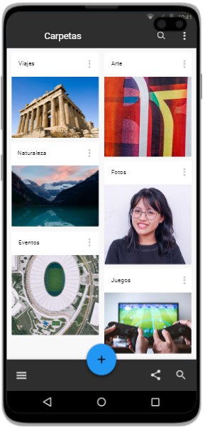

**Carpetas:**

**Petición:** GET

**Endpoint:** www.nombredominio.com/ **folders/:** **id_user**

**Output:**

List <Folder> [

{

“Id_folder”: int,

“id_user”: int,

“name_folder”: String,

“date”: Date,

},

]

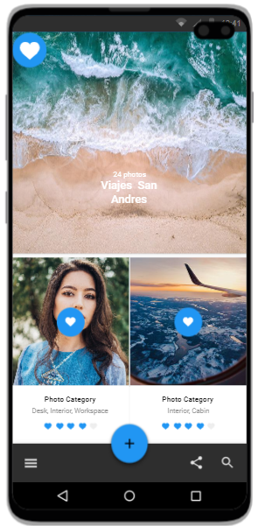**Favoritos:**

**Petición:** GET

**Endpoint:** www.nombredominio.com/ **favorites/:** **id_user**

**Output:**

List <Photo> [

{

“id_user”: int,

“Id_photo”: int,

“date”: Date,

“id_folder”: int,

“favorite”: “true”,

“url_image”: String

},

]

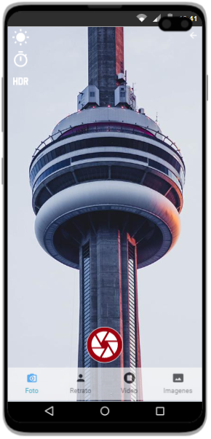**Cámara:**

**Petición:** POST

**Endpoint:** www.nombredominio.com/**home/:** **id_user**

**Input:**

Photo: {

“id_user”: int,

“date”: Date,

}

**Output:**

Photo: {

“Id_user”: int,

“Id_photo”: int,

“date”: Date,

“id_folder”: int,

“favorite”: Boolean,

“url_image”: String,

}

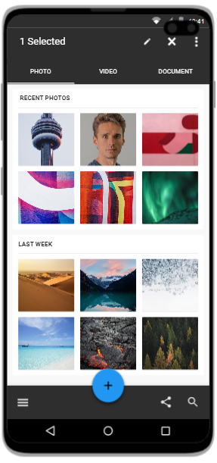**Recientes:**

**Petición:** GET

**Endpoint:** www.nombredominio.com/ **recentPhotos/:id_user**

**Output:**

List <Photo> [

{

“id_user”: int,

“Id_photo”: int,

“date”: Date,

“id_folder”: int,

“favorite”: Boolean,

“url_image”: String

},

]

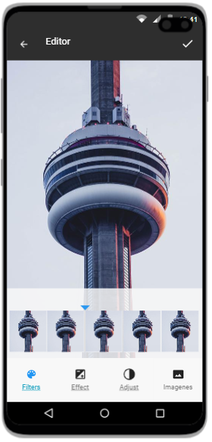**Editar:**

**Petición:** PUT

**Endpoint:** www.nombredominio.com/**editPhoto/:** **id_user/:id_photo**

**Input:**

Photo: {

“Id_photo”: int,

“date”: Date,

},

**Output:**

Photo: {

“Id_user”: int,

“Id_photo”: int,

“date”: Date,

“id_folder”: int,

“favorite”: Boolean,

“url_image”: String,

}